Appendix X
RMI-IIOP and JNDI
To help you to truly understand EJB, this appendix explains the technologies that EJB depends upon--namely Java RMI-IIOP and the Java Naming and Directory Interface (JNDI).
The goal of this appendix is to teach you enough about RMI-IIOP and JNDI so that you can be productive in an EJB environment. This tutorial will cover the basics, but is by no means a complete RMI-IIOP and JNDI tutorial, and for good reason--most organizations will not need to use these technologies beyond the extent we describe in this appendix, and your reading time is valuable.
If you'd like to learn more about these technologies, there are free tutorials, articles, and links to other information available. See http://www.TheServerSide.com for more.
Java RMI-IIOP
Java RMI-IIOP (which stands for Java Remote Method Invocation over the Internet Inter-ORB Protocol) is J2EE's de-facto mechanism for performing simple, powerful networking. RMI-IIOP allows you to write distributed objects in Java, enabling objects to communicate in memory, across Java Virtual Machines, and across physical devices.
Note
RMI-IIOP is not your only choice for performing remote method invocations in Java. You can also use Java Remote Method Invocation (RMI). RMI was the original way to perform remote method invocations in Java, and uses the java.rmi package. RMI-IIOP is a special version of RMI that is compliant with CORBA, and uses both java.rmi as well as javax.rmi.
RMI has some interesting features not available in RMI-IIOP. But EJB and J2EE mandate that you use RMI-IIOP, and not RMI. Therefore we will not cover RMI.
If you wish to learn more about why RMI-IIOP was invented as an extension of RMI, and also survey the CORBA compatibility features of RMI-IIOP, please read Appendix X.
Remote Method Invocations
A remote procedure call (RPC) is a procedural invocation from a process on one machine to a process on another machine. RPCs enable traditional procedures to reside on multiple machines, yet still remain in communication. They are a simple way to perform cross-process or cross-machine networking.
A remote method invocation in Java takes the RPC concept one step further and allows for distributed object communications. RMI-IIOP allows you to invoke methods on objects remotely, not merely procedures. You can build your networked code as full objects. This yields the benefits of an object-oriented programming, such as inheritance, encapsulation, and polymorphism.
Remote method invocations are by no means simple. Below are just some of the issues that arise:
Marshalling and unmarshalling. Remote method invocations (as well as RPCs) allow you to pass parameters, including Java primitives and Java objects, over the network. But what if the target machine represents data differently than the way you represent data? For example, what happens if one machine uses a different binary standard to represent numbers? The problem becomes even more apparent when you start talking about objects. What happens if you send an object reference over the wire? That pointer is not usable on the other machine because that machine’s memory layout is completely different from yours. Marshalling and unmarshalling is the process of massaging parameters so that they are usable on the machine being invoked on remotely. It is the packaging and unpackaging of parameters so that they are usable in two heterogeneous environments. As we shall see, this is taken care of for you by Java and RMI-IIOP.
Parameter passing conventions. There are two major ways to pass parameters when calling a method: pass-by-value and pass-by-reference, as shown in Figure X.X. When you pass by value, you pass a copy of your data so that the target method is using a copy, rather than the original data. Any changes to the argument are reflected only in the copy, not the original. Pass-by-reference, on the other hand, does not make a copy. With pass-by-reference, any modifications to parameters made by the remote host affect the original data. The flexibility of both the pass-by-reference and pass-by-value models are advantageous to have, and RMI-IIOP supports both. We’ll see how in the pages to come.
Network or machine instability. With a single JVM application, a crash of the JVM brings the entire application down. But consider a distributed object application, which has many JVMs working together to solve a business problem. In this scenario, a crash of a single JVM should not cause the distributed object system to grind to a halt. To enforce this, remote method invocations need a standardized way of handling a JVM crash, a machine crash, or network instability. When some code performs a remote invocation, the code should be informed of any problems encountered during the operation. RMI-IIOP performs this for you, abstracting out any JVM, machine, or network problems from your code.
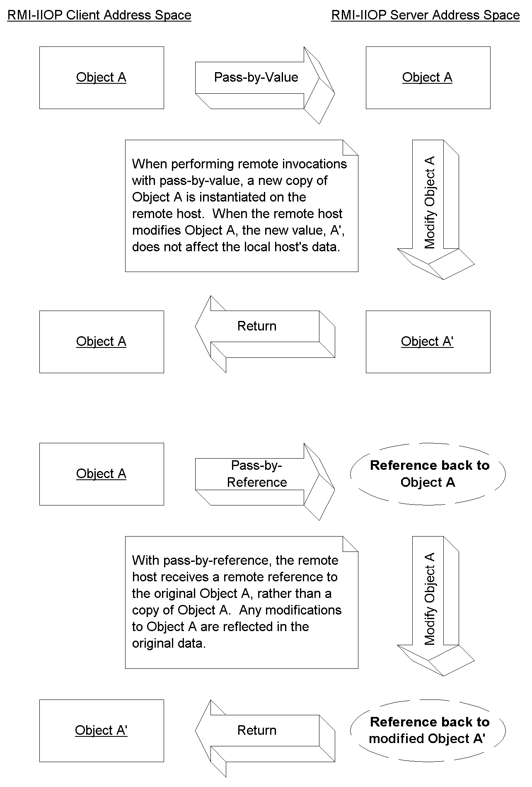
Figure X.X Pass-by-value versus pass-by-reference.
As you can see, there’s a lot involved in performing remote method invocations. RMI-IIOP contains measures to handle many of these nasty networking issues for you. This reduces the total time spent dealing with the distribution of your application, allowing you to focus on the core functionality.
J2EE 1.3-compliant servers are required to ship RMI-IIOP implementations to enable you to perform networking. Your RMI-IIOP code is then portable to any hardware or operating system on which that these implementations execute. Contrast this with proprietary, platform-dependent RPC libraries, and you can see some real value in RMI-IIOP.
The Remote Interface
We begin our exploration of RMI-IIOP by reviewing one of object-oriented design’s great programming practices--the separation of the interface of code from its implementation.
The interface defines the exposed information about an object, such as the names of its methods and what parameters those methods take. It’s what the client works with. The interface masks the implementation from the viewpoint of clients of the object, so clients deal only with the end result: the methods the object exposes.
The implementation is the core programming logic that an object provides. It has some very specific algorithms, logic, and data.
By separating interface from implementation, you can vary an object’s proprietary logic without changing any client code. For example, you can plug in a different algorithm that performs the same task more efficiently.
RMI-IIOP makes extensive use of this concept. All networking code you write is applied to interfaces, not implementations. In fact, you must use this paradigm in RMI-IIOP--you do not have a choice. It is impossible to perform a remote invocation directly on an object implementation. You can operate solely on the interface to that object’s class.
Therefore, when using RMI-IIOP, you must build a custom interface, called a remote interface. This remote interface should extend the interface java.rmi.Remote. Your interface should have within it a copy of each method your remote object exposes.
We'll now begin to build a simple example illustrating the basics of RMI-IIOP. In this example, a remote object exposes one method, generate(). generate() returns a new, unique long number each time its called. This is useful, for examples, when needing to generate primary keys for data, such as entity beans (discussed in Chapter X).
The following code snippet is a valid remote interface:
import java.rmi.Remote;
import java.rmi.RemoteException;

/**
* The remote interface for the remote object. Clients use this
* remote interface to perform any operations on the remote object.
*/
public interface IPKGenerator extends Remote {
public long generate() throws RemoteException;
}
Source X.X IPKGenerator.java.
Client code that wants to call methods on your remote object must operate on IPKGenerator. Notice also that each method must also throw a java.rmi.RemoteException. A RemoteException is thrown when there is a problem with the network, such as a machine crashing or the network dying.
Note
With RMI-IIOP, you can never fully separate your application from the network. Somewhere, at some point, you’ll need to deal with Remote Exceptions being thrown due to networking issues. Some may consider this a limitation of RMI-IIOP because the network is not entirely “seamless,” because Remote Exceptions force you to differentiate a local method from a remote method. But in some ways, this is an advantage of RMI-IIOP as well. Interlacing your code with Remote Exceptions forces you to think about the network and encourages distributed object developers to consider issues such as the network failing, the size of parameters going across the network, and more.
The Remote Object Implementation
Remote objects are networked object implementations that can be called by another JVM. They implement a remote interface, and thus expose methods that can be invoked by remote clients.
The physical locations of remote objects and the clients that invoke them are not important. For example, it’s possible for a client running in the same address space as a remote object to invoke a method on that object. It’s also possible for a client across the Internet to do the same thing. To the remote object, both invocations appear to be the same.
To make your object a remote object available to be invoked on by remote hosts, your remote class must perform one of the following steps:
Extend the class javax.rmi.PortableRemoteObject. PortableRemoteObject is a base class from which you can derive your remote objects. When your remote object is constructed, it will automatically call the PortableRemoteObject’s constructor, which will make the object available to be called remotely.
Don’t extend javax.rmi.PortableRemoteObject. Perhaps your remote object class needs to inherit implementation from another custom class. In this case, because Java does not allow for multiple implementation inheritance, you cannot extend PortableRemoteObject. If you do this, you must manually export your object so that it is available to be invoked on by remote hosts. To export your object, call javax.rmi.PortableRemoteObject.exportObject().
Now let’s create the remote object class. This class implements the IPKGenerator interface, and it is shown in Source X.X.
import java.rmi.RemoteException;
import javax.rmi.PortableRemoteObject;

/**
* The remote object which generates primary keys
*/
public class PKGenerator
extends PortableRemoteObject
implements IPKGenerator {

/*
* Our remote object's constructor
*/
public PKGenerator() throws Exception, RemoteException {

/*
* Since we extend PortableRemoteObject, the super
* class will export our remote object here.
*/
super();
}

/*
* Generates a unique primary key
*/
public synchronized long generate() throws RemoteException {
return i++;
}

private static long i = System.currentTimeMillis();
}
Source X.X PKGenerator.java
In our remote object constructor, the superclass will make our object available to be called remotely. This makes the object available at a random port number. Once the remote object’s constructor is complete, this object will be available forever for any Virtual Machine to invoke on--that is, until someone calls unexportObject().
Issues with our primary key generation algorithm
Our primary key generation algorithm is to simply increment a number each time someone calls our server. This generator overcomes two common challenges when writing an RMI implementation:@@@COMP: UL within SBT@@@
Threading. RMI-IIOP allows many clients to connect to a server at once. Thus our remote object implementation may have many threads running inside of it. But when generating primary keys, we never want to generate a duplicate key, because our keys are not unique, and thus would not be good candidates to use in a database. Therefore it is important to have the synchronized block around the generate() method, so that only one client can generate a primary key at once.
JVM crashes. We must protect against a JVM crash (or hardware failure). Thus we initialize our generator to the current time (the number of milliseconds that have elapsed since 1970). This is to ensure that our primary key generator increases monotonically (that is, primary keys are always going up in value) in case of a JVM crash. Note that we haven't considered daylight savings time resulting in duplicate keys. If we were to use this code in production we would need to account for that.
Note that this primary key generator has its own shortcoming as well: for someone to generate a primary key, they need to invoke a remote method, which could be a performance bottleneck.
If you need to generate primary keys in production, see Chapter X for a complete discussion of strategies.
Stubs and Skeletons
Now that we've seen the server code, let's look at the architecture behind how the networking is achieved in RMI-IIOP. One of the benefits of RMI-IIOP is an almost illusionary, transparent networking. You can invoke methods on remote objects just as you would invoke a method on any other Java object. In fact, RMI-IIOP completely masks whether the object you’re invoking on is local or remote. This is called local/remote transparency.
But local/remote transparency is not as easy as it sounds. To mask the fact that you’re invoking on an object residing on a remote host, RMI-IIOP needs to somehow simulate a local object that you can invoke on. This local object is called a stub, and it is responsible for accepting method calls locally and delegating those method calls to their actual object implementations, which are possibly located across the network. This effectively makes every remote invocation appear to be a local invocation. You can think of a stub as a placeholder for an object that knows how to look over the network for the real object. Because you invoke on local stubs, all the nasty networking issues are hidden behind the scenes.
Stubs are only half of the picture. We’d like the remote objects themselves--the objects that are being invoked on from remote hosts--to not worry about networking issues as well. Just as a client invokes on a stub that is local to that client, your remote object needs to accept calls from a skeleton that is local to that remote object. Skeletons are responsible for receiving calls over the network (perhaps from a stub) and delegating that call to the remote object implementation. This is shown in Figure X.X.
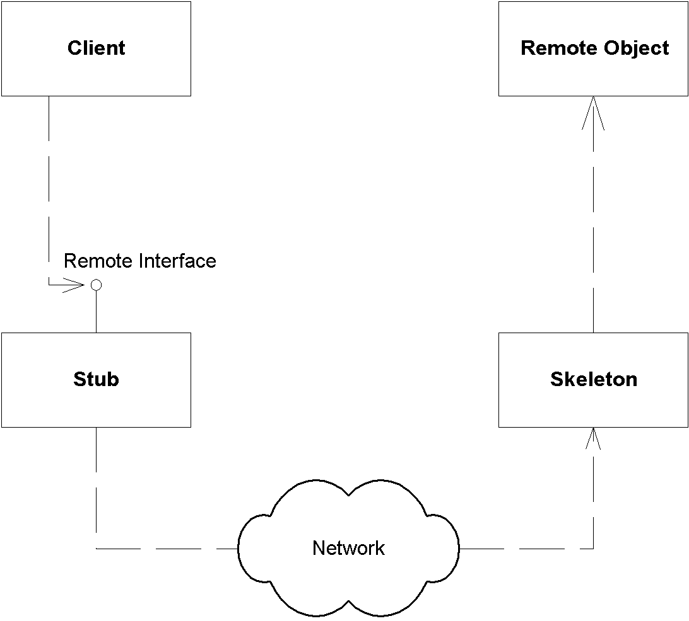
Figure X.X Stubs and skeletons.
Your RMI-IIOP implementation (that is, your J2EE server) should provide a means to generate the needed stubs and skeletons, thus relieving you of the networking burden. Typically this is achieved through command-line tools. For example, Sun's J2EE reference implementation ships with a tool called rmic (which stands for the RMI compiler) to generate stub and skeleton classes. As you can see from Figure X.X, you should then deploy the stub on the client machine, and the skeleton on the server machine.
Object Serialization and Parameter Passing
One of the more interesting responsibilities of stubs and skeletons is to handle your parameters. This next section discusses how parameters are passed in Java RMI-IIOP. We also explore the power of object serialization and how it assists in parameter passing.
Passing by Value
When invoking a method using RMI-IIOP, all parameters to the remote method are passed by value. This means that when a client calls a server, all parameters are copied from one machine to the other.
Passing objects by value is very different from the Java programming language. When you call a method in Java and pass an Object as a parameter, that object is passed by reference. More specifically, the reference to the object is copied, but the actual object’s data is not.
There’s a big problem with passing by value. If you’re trying to pass an object over the network and that object contains references to other objects, how are those references resolved on the target machine? A memory address on one machine does not map to the same memory address on another machine. Also, the referenced object may not even exist on the target machine. How do we get around this?
Object Serialization
Java introduces the concept of object serialization to handle this problem. Serialization is the conversion of a Java object into a bit-blob representation of that object. You can send bit-blobs anywhere. For example, you can use object serialization as an instant file-format for your objects, and save them to your hard disk. RMI-IIOP also uses object serialization to send parameters over the network. When you’re ready to use the object again, you must deserialize the bit-blob back into a Java object. Then it’s magically usable again.
The Java language handles the low-level details of serialization. In most cases, you don’t need to worry about any of it. In order to tell Java that your object is serializable, your object must implement the java.lang.Serializable interface. That’s all there is to it--take this one simple step, and let Java handle the rest. java.lang.Serializable defines no methods at all--it’s simply a marker interface that identifies your object as something that can be serialized and deserialized.
You can provide your own custom serialization by implementing the writeObject() method on your object, or custom deserialization by implementing readObject(). This might be useful if, for example, you’d like to perform some sort of compression on your data before your object is converted into a bit-blob, and decompression after the bit-blob is restored to an object.
Figure X.X shows the serialization/deserialization process.
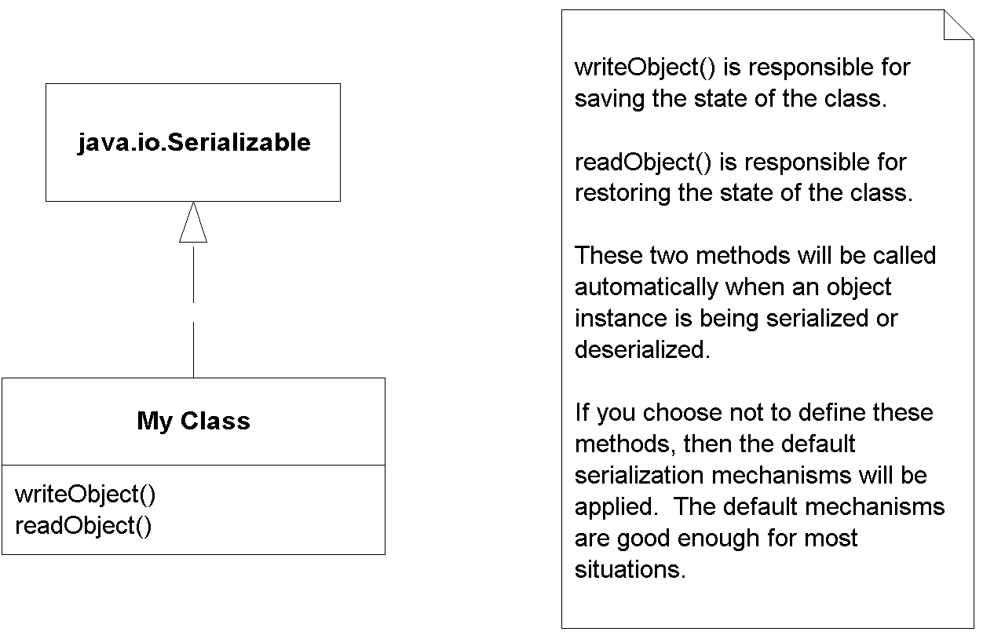
Figure X.X The Java serialization process.
Rules for Serialization
Java serialization has the following rules for member variables held in serialized objects:
- Any basic primitive type (int, char, etc.) is automatically serialized with the object and is available when deserialized.
- Java Objects can be included with the serialized bit-blob or not; it’s your choice. The way you make your choice is as follows:
- Objects marked with the transient keyword are not serialized with the object and are not available when deserialized.
- Any object that is not marked with the transient keyword must implement java.lang.Serializable. These objects are converted to bit-blob format along with the original object. If your Java objects neither are transient nor implement java.lang.Serializable, a NotSerializableException is thrown when writeObject() is called.
Thus, when you serialize an object, you also serialize all nontransient subobjects as well. This means you also serialize all nontransient sub-subobjects (the objects referenced from the subobjects). This is repeated recursively for every object until the entire reference graph of objects is serialized. This recursion is handled automatically by Java serialization, as shown in Figure X.X. You simply need to make sure that each of your member objects implements the java.lang.Serializable interface.
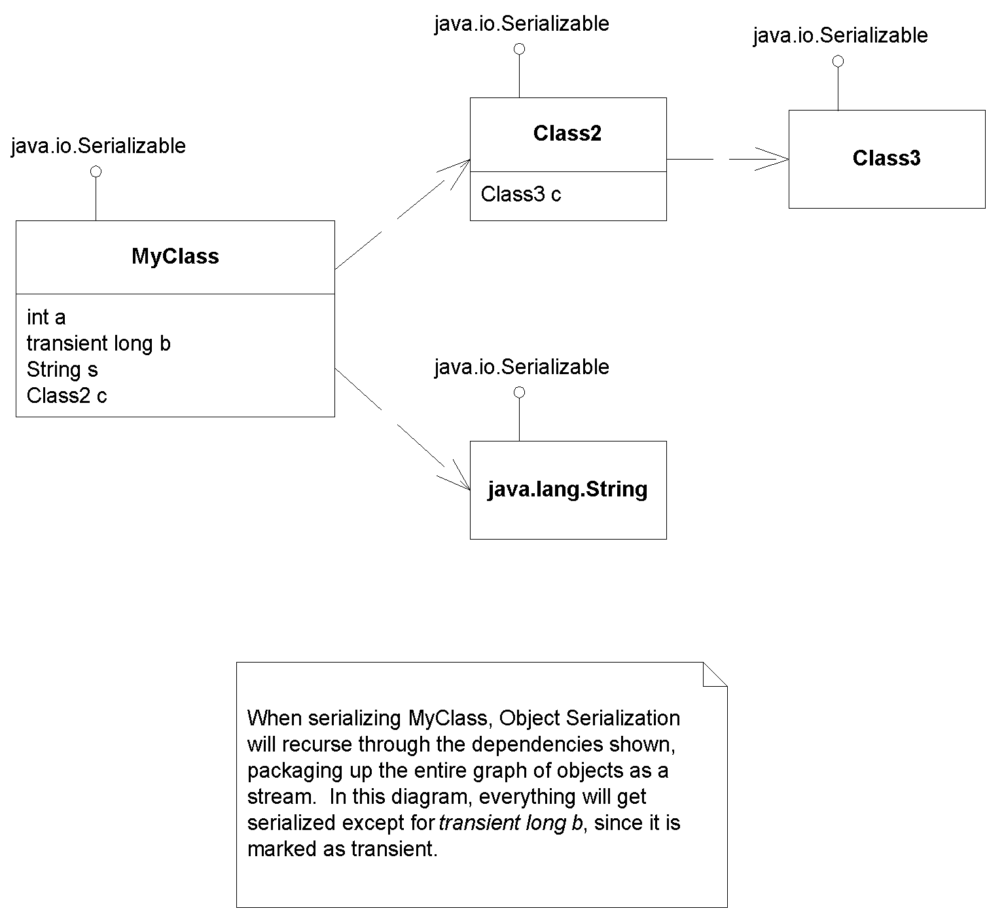
Figure X.X Object serialization recursion.
What Should You Make Transient?
How do you know which member variables should be marked transient and which should not? Here are some good reasons why you would want to mark an object as transient:
- The object is very large. Large objects may not be suitable for serialization because operations you do with the serialized blob may be very intensive. Examples here include saving the blob to disk or transporting the blob across the network.
- The object represents a resource that cannot be reconstructed on the target machine. Some examples of such resources are database connections and sockets.
- The object represents sensitive information that you do not want to pass in a serialized stream.
Note that object serialization is not free--it is a very heavyweight operation for large graphs of objects. Make sure you take this into account when designing your distributed object application.
Object Serialization and RMI-IIOP
Java RMI-IIOP relies on object serialization for passing parameters via remote method invocations. This is shown in Figure X.X.
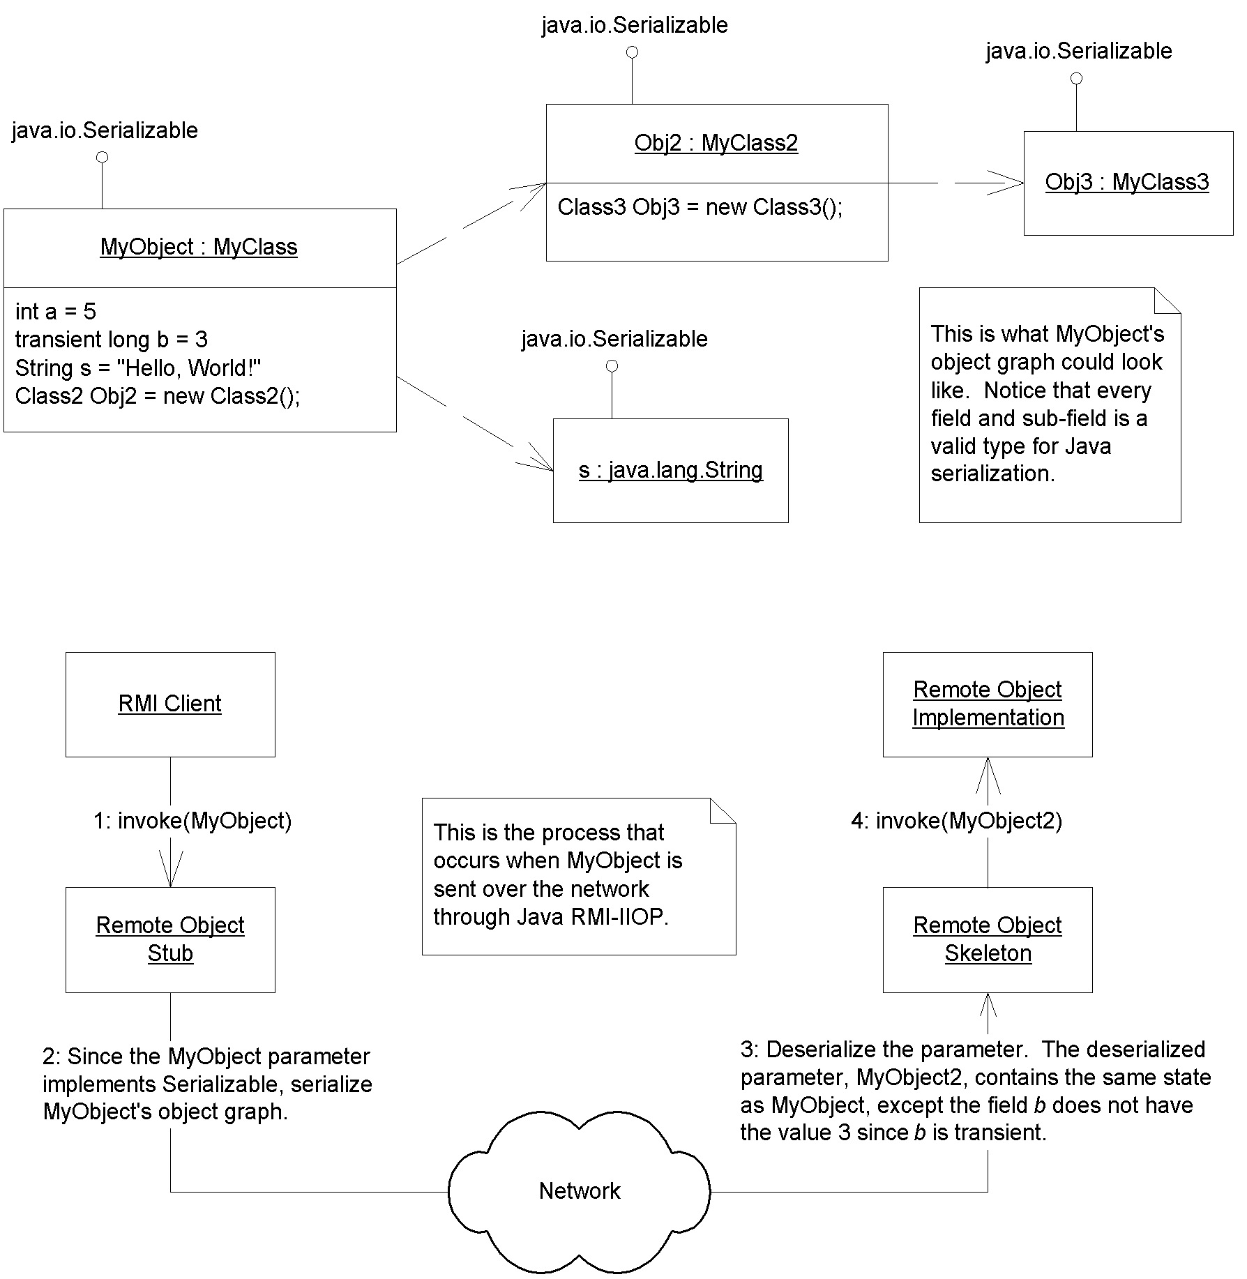
Figure X.X Java RMI-IIOP and Object Serialization.
Figure X.X shows how RMI-IIOP handles pass by value, where an entire graph of objects is serialized into a bit-blob, sent across the network, and then deserialized on the target machine. But passing parameters by value can lead to inefficiencies. What if your referenced graph of objects is very large? What if you have lots of state to send across the network? The ensuing network lag from performing the invocation may be unacceptable.
Because of this, there is another way to pass arguments. RMI-IIOP simulates a pass-by-reference convention, which means the arguments are not copied over. Rather, the server modifies the client's copy of the parameter.
If you want to pass a parameter by reference, then the parameter must itself be a remote object. The parameter is thus an object that is callable remotely. When the client calls the server, the RMI-IIOP runtime sends a stub to that remote object to the server. The server can perform a callback on that stub, which connects the server to the remote object living on the client machine. This is shown in Figure X.X.
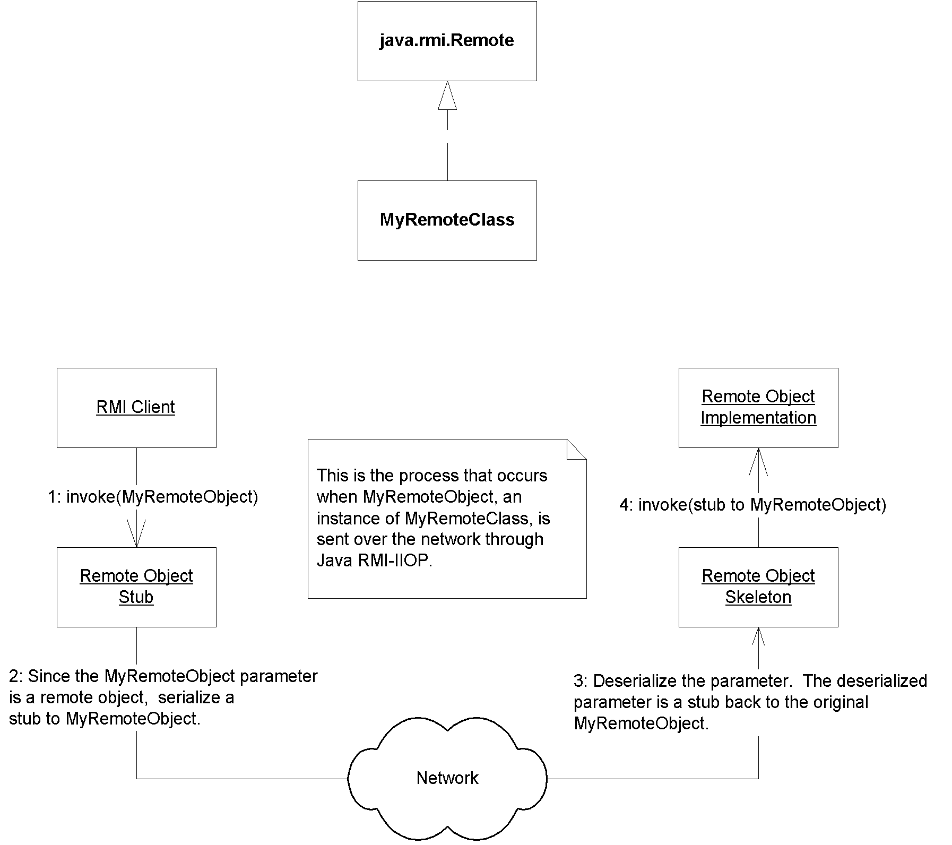
Figure X.X Pass by reference with Java RMI-IIOP.
The best way to understand this paradigm is by analogy. In Java programming language, when you pass an object as a parameter, then the object reference is copied. In RMI-IIOP, when you pass an object as a parameter, then the stub is copied. Both of these strategies achieve pass-by-reference, because they are cloning the thing that points to the object, rather than the object itself.
Because Java RMI-IIOP stubs are also serializable, they are passable over the network as a bit-blob. This is why earlier we said that all parameters in Java RMI-IIOP are passed by-value. Thus, Java RMI-IIOP only simulates pass by reference by passing a serializable stub, rather than serializing the original object. By making your parameters remote objects, you can effectively avoid the network lag in passing large objects.
In summary, we have the following rules for passing objects using Java RMI-IIOP:
- All Java basic primitives are passed by value when calling methods remotely. This means copies are made of the parameters. Any changes to the data on the remote host are not reflected in the original data.
- If you want to pass an object over the network by value, it must implement java.lang.Serializable. Anything referenced from within that object must follow the rules for Java Serialization. Again, any changes to the data on the remote host are not reflected in the original data.
- If you want to pass an object over the network by reference, it must be a remote object, and it must implement java.rmi.Remote. A stub for the remote object will be serialized and passed to the remote host. The remote host can then use that stub to invoke callbacks on your remote object. There is only one copy of the object at any time, which means that all hosts are calling the same object.
Now that you understand parameter passing, let's move on. For us to complete our RMI-IIOP sample application, we need some way to publish the server and have the client locate that server. This process is called bootstrapping, and is achieved via the Java Naming and Directory Interface (JNDI). Let's put our RMI-IIOP example on hold while we learn about JNDI, and return later to complete the example.
The Java Naming and Directory Interface (JNDI)
The Java Naming and Directory Interface (JNDI) is a J2EE API that provides a standard interface for locating users, machines, networks, objects, and services. For example, you can use JNDI to locate a printer on your corporate Intranet. You can also use it to locate a Java object or to connect with a database. JNDI is used in EJB, RMI-IIOP, JDBC, and more. It is the standard way of looking things up over the network.
Naming and Directory Services
To understand JNDI, we must first understand the concept of naming and directory services.
A naming service is analogous to a telephone operator. When you want to call up someone over the phone and you don’t know that person’s phone number, you can call your telephone company’s information service operator to look up the person you want to talk with. You supply the telephone operator with the name of the person. The operator then looks up the phone number of the person you want to speak with and can dial the number for you, connecting you to that person.
A naming service is an entity that performs the following tasks:
- It associates names with objects. We call this binding names to objects. This is very similar to a telephone company’s associating a person’s name with a specific residence’s telephone number.
- It provides a facility to find an object based on a name. We call this looking up or searching for an object. This is similar to a telephone operator finding a person’s telephone number based on that person’s name and connecting the two people together.
Naming services are everywhere in computing. When you want to locate a machine on the network, the Domain Name System (DNS) is used to translate a machine name to an IP address. If you look up “wiley.com” on the Internet, the name “wiley.com” is translated into the object (which happens to be a String) 199.171.201.14 by the DNS.
Another example of naming occurs in file systems. When you access a file on your hard disk, you supply a name for the file such as “c:\autoexec.bat” or “/etc/fstab.” How is this name translated into an actual file of data? A File System Naming Service can be consulted to provide this functionality.
In general, a naming service can be used to find any kind of generic object, like a file handle on your hard drive or a printer located across the network. But one type of object is of particular importance: a directory object (or directory entry). A directory object is different from a generic object because you can store attributes with directory objects. These attributes can be used for a wide variety of purposes.
For example, you can use a directory object to represent a user in your company. You can store information about that user, such as the user’s password, as attributes in the directory object. If you have an application that requires authentication, you can store a user’s login name and password in directory object attributes. When a client connects to your application, the client supplies a login name and password, which you can compare with the login name and password that are stored as a directory object’s attributes. If the data matches, the user is authenticated. If the data doesn’t match, your application can return an error. You can also store other attributes, too, besides a login name and password, such as a user’s e-mail address, phone number, and postal address.
A directory service is a naming service that has been extended and enhanced to provide directory object operations for manipulating attributes. A directory is a system of directory objects, all connected. Some examples of directory products are Netscape Directory Server and Microsoft’s Active Directory. Your company probably uses a directory to store internal company information--locations of computers, current printer status, personnel data, and so on.
What does a directory look like internally? The directory’s contents--the set of connected directory objects--usually forms a hierarchical tree-like structure. Why would you want a tree-like structure? Well, a tree’s form suggests the way a real-world company is organized. For example, the root (or top node) of your directory tree can represent your entire company. One branch off the root could represent people in the company, while another branch could represent network services. Each branch could have subtrees that decrease in granularity more and more, until you are at individual user objects, printer objects, machine objects, and the like. This is illustrated in Figure X.X.
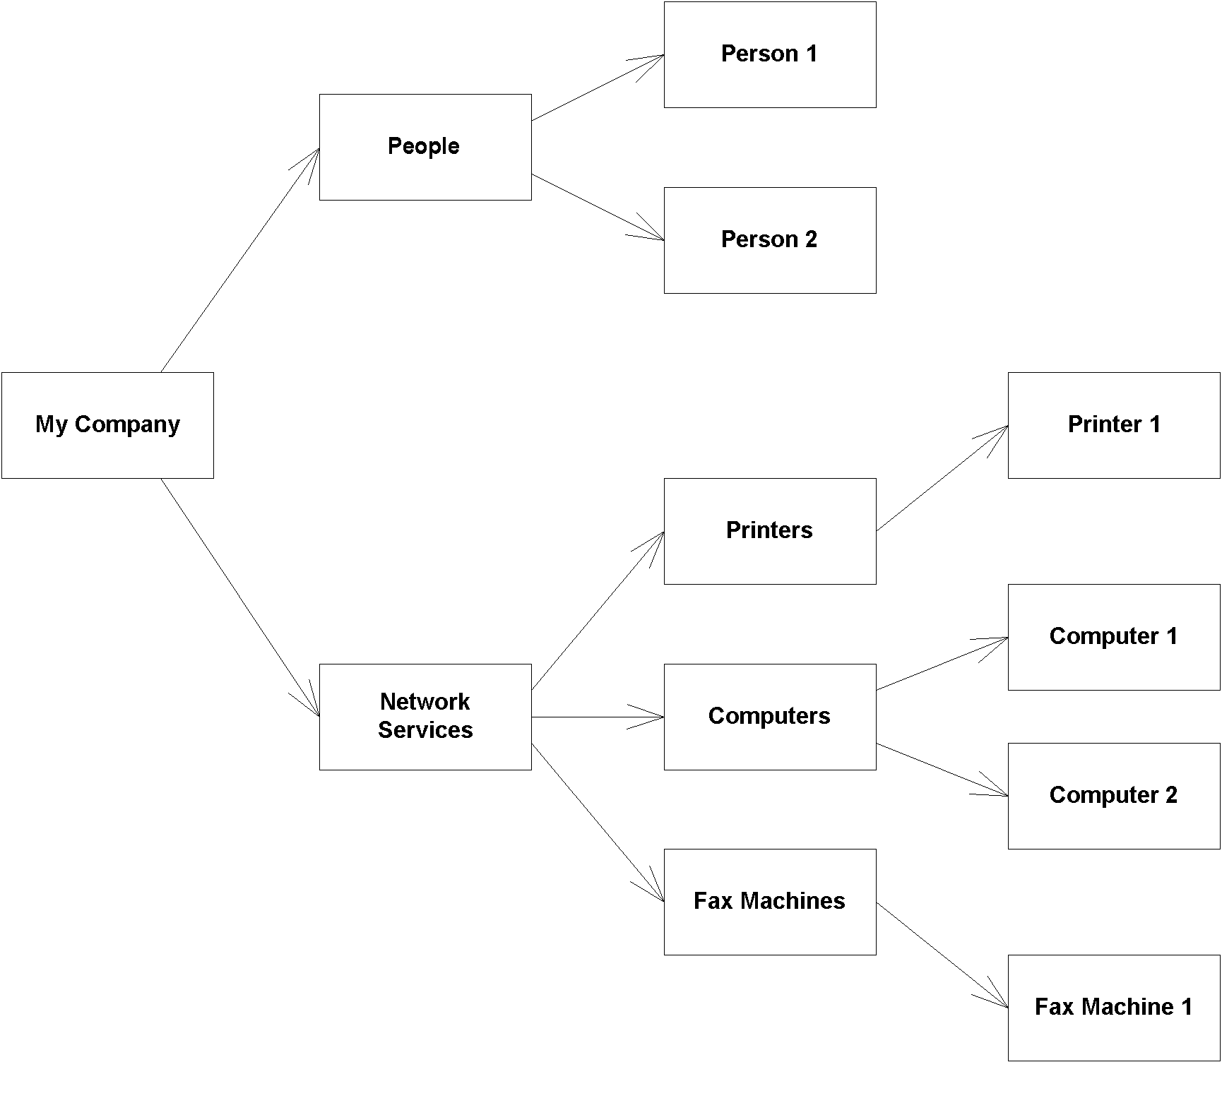
Figure X.X A hierarchical directory structure.
All in all, directories are not very different from databases. A database can store arbitrary data, just like a directory. Databases provide query operations to look up items in a database, just like directories. You can think of a directory as a scaled-down, simplified database. In fact, most directories are implemented by a database behind the scenes.
Problems with Naming and Directories
There are many popular naming and directory products out today. Directory vendors differentiate their product lines by offering different types of services. Unfortunately, this leads to different naming and directory standards. And each directory standard has a different protocol for accessing the directory. For example, directories based on the Lightweight Directory Access Protocol (LDAP) are accessed differently than those based on the Network Information System (NIS) or Novell’s Network Directory System (NDS).
This means that if you want to switch directory vendors, you need to rewrite all of your client code that accesses the directory. It also means you need to download a new library, learn a new API, and test new code each time you use a different directory.
Initially, LDAP was meant to resolve this problem by becoming the ubiquitous protocol for directories. LDAP is very straightforward and is being adopted quickly by the industry--IBM’s Lotus Notes and Microsoft’s Active Directory both are LDAP-based. However, not all directory products are LDAP-based.
Enter JNDI
JNDI is a system for Java-based clients to interact with naming and directory systems. JNDI is a bridge over naming and directory services--a beast that provides one common interface to disparate directories. Users who need to access an LDAP directory use the same API as users who want to access an NIS directory or Novell’s directory. All directory operations are done through the JNDI interface, providing a common framework.
Benefits of JNDI
The following surveys the advantages that JNDI has to offer:
- You only need to learn a single API to access all sorts of directory service information, such as security credentials, phone numbers, electronic and postal mail addresses, application preferences, network addresses, machine configurations, and more.
- JNDI insulates the application from protocol and implementation details.
- You can use JNDI to read and write whole Java objects from directories.
- You can link different types of directories, such as an LDAP directory with an NDS directory, and have the combination appear to be one large, federated directory. The federated directory appears to be one contiguous directory to the client.
In J2EE, you can use JNDI for many purposes. These include:
- Using JNDI to acquire a reference to the Java Transaction API (JTA) UserTransaction interface
- Using JNDI to connect to resource factories, such as JDBC drivers or Java Message Service (JMS) drivers
- Using JNDI for beans to look up other beans
See Chapter X for examples of achieving these operations.
JNDI Architecture
JNDI is made up of two halves: the client API and the Service Provider Interface (SPI). The client API allows Java code to perform directory operations. This API is uniform for all types of directories. The client API is what you will be spending the most time using.
The JNDI SPI is an interface to which naming and directory service vendors can plug in. The SPI is the converse of the API: While the API allows clients to code to a single, unified interface, the SPI allows naming and directory service vendors to fit their particular proprietary protocols into the system, as shown in Figure X.X. This allows for client code to leverage proprietary naming and directory services in Java while maintaining a high level of code portability.
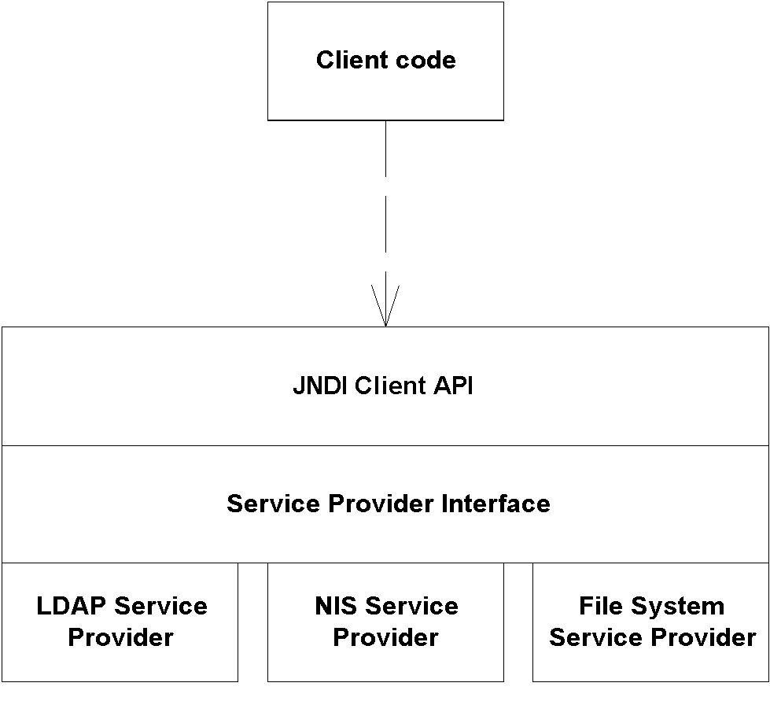
Figure X.X JNDI architecture.
JNDI’s architecture is somewhat like the Java Database Connectivity package (JDBC):
- In JDBC, there is one uniform client API for performing database operations. In JNDI, naming and directory service clients invoke a unified API for performing naming and directory operations.
- In JDBC, relational database vendors provide JDBC drivers to access their particular databases. In JNDI, directory vendors provide service providers to access their specific directories. These providers are aware of specific directory protocols, and they plug in to the JNDI SPI.
For example, Sun Microsystems gives away an LDAP service provider for free. The LDAP service provider knows how to map a JNDI client API operation into an LDAP operation. It then executes the LDAP operation on an LDAP directory, using the specific LDAP protocol.
There are a number of available JNDI service providers today, including LDAP, NIS, Novell NDS, SLP, CORBA, File System, RMI-IIOP, and many more. The JNDI homepage (http://java.sun.com/products/jndi) has a list of available service providers.
J2EE servers bundle a JNDI implementation with their product. Typically this is a custom implementation provided by the J2EE server vendor. JNDI then just becomes another service provided by the server, along with RMI-IIOP, JMS, and so-on. Many servers ship JNDI implementations that are fault-tolerant, providing a high level of availability. These JNDI implementations are intended to integrate together with other the J2EE services, such as RMI-IIOP, JDBC, EJB, and JMS.
JNDI Concepts
We begin our JNDI exploration with naming concepts. There are several kinds of names in JNDI:
- An atomic name is a simple, basic, indivisible component of a name. For example, in the string /etc/fstab, etc and fstab are atomic names.
- A compound name is zero or more atomic names put together. In the previous example, the entire string /etc/fstab is a compound name.
A binding is an association of a name with an object. For example, the filename autoexec.bat in the Windows file system has a binding to the file data on your hard disk. Your c:\windows folder is a name that is bound to a folder on your hard drive. Note that a compound name such as /usr/people/ed/.cshrc consists of multiple bindings, one to usr, one to people, one to ed, and one to .cshrc.
A context is an object that contains zero or more bindings. Each binding has a distinct atomic name. So, for example, in the UNIX file system, let’s consider a folder named /etc that contains files named mtab and exports. In JNDI, the /etc folder is a context containing bindings with atomic names mtab and exports. Each of the mtab and exports atomic names is bound to a file on the hard disk.
To expand this further, consider a folder named /usr with subfolders /usr/people, /usr/bin, and /usr/local. Here, the /usr folder is a context that contains the people, bin, and local atomic names. Each of these atomic names is bound to a subfolder. In JNDI terms, these subfolders are called subcontexts. Each subcontext is a full-fledged context in its own right, and it can contain more name-object bindings, such as other files or other folders. Figure X.X depicts the concepts we have learned so far.
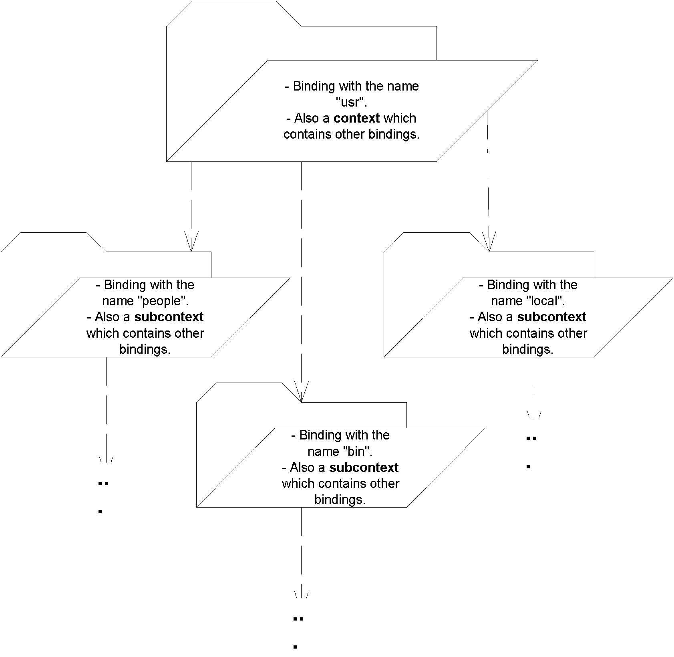
Figure X.X JNDI naming concepts.
Naming Systems, Namespaces, and Composite Names
A naming system is a connected set of contexts. For example, a branch of an LDAP tree could be considered a naming system, as could a folder tree in a file system. Unfortunately, naming systems each have a different syntax for accessing contexts. For example, in an LDAP tree, a compound name is identified by a string such as “cn=Ed Roman, ou=People, o=Middleware-Company.com, c=us”, whereas a file system compound name might look like “c:\java\lib\tools.jar.”
Within a naming system, a namespace is all the names contained within that naming system. Your hard drive’s entire collection of filenames and directories or folders is your hard drive file system’s namespace; the set of all names in an LDAP directory’s tree is an LDAP server’s namespace. Naming systems and namespaces are shown in Figure X.X.
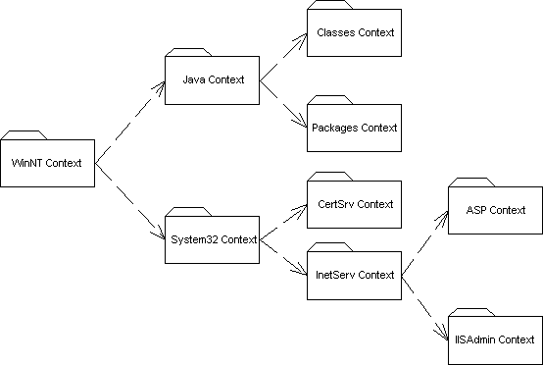
Figure X.X Naming systems and namespaces.
A composite name is a name that spans multiple naming systems. For example, on the Web, the URL http://java.sun.com/products/ejb/index.html is composed from the following namespaces:
- http comes from the URL scheme-id namespace. You can use other scheme-ids, such as ftp and telnet. This namespace defines the protocol you use to communicate.
- java.sun.com uses the Domain Name Service (DNS) to translate machine names into IP addresses.
- products and ejb and index.html are from the file system namespace on the Web server machine.
By linking multiple naming systems like the URL above, we can arrive at a unified composite namespace (also called a federated namespace) containing all the bindings of each naming system.
Initial Context Factories
One question commonly asked by our students in our training classes is, if you are to traverse a composite namespace, how do you know which naming system to look into first? For example, which namespace do you first look in when traversing the string http://www.TheServerSide.com/events/index.jsp?
The starting point of exploring a namespace is called an initial context. An initial context simply is the first context you happen to use. An initial context is a starting point for performing all naming and directory operations.
To acquire an initial context, you use an initial context factory. An initial context factory is responsible for churning out initial contexts. An initial context factory basically is your JNDI driver. For example, there is an LDAP initial context factory, as well as a File System initial context factory. These initial context factories know the specific semantics of a particular directory structure. They know how to acquire an arbitrary context that you can use as an initial starting context for traversing a directory structure.
Initial context factories are used for bootstrapping, or jump-starting, your naming and directory service operations. You use an initial context factory as a bootstrapping mechanism for identifying an initial naming system.
When you acquire an initial context, you must supply the necessary information for JNDI to acquire that initial context. For example, if you're trying to access a JNDI implementation that runs within a J2EE server, you might supply:
- The IP address of the J2EE server
- The port number that the J2EE server accepts
- The starting location within the JNDI tree
- Any username/password necessary to use the J2EE server.
You could use this same paradigm to access an LDAP server - just substitute the word 'LDAP server' for 'J2EE server' in the bulleted list above.
Initial contexts and composite namespaces are illustrated in Figure X.X.
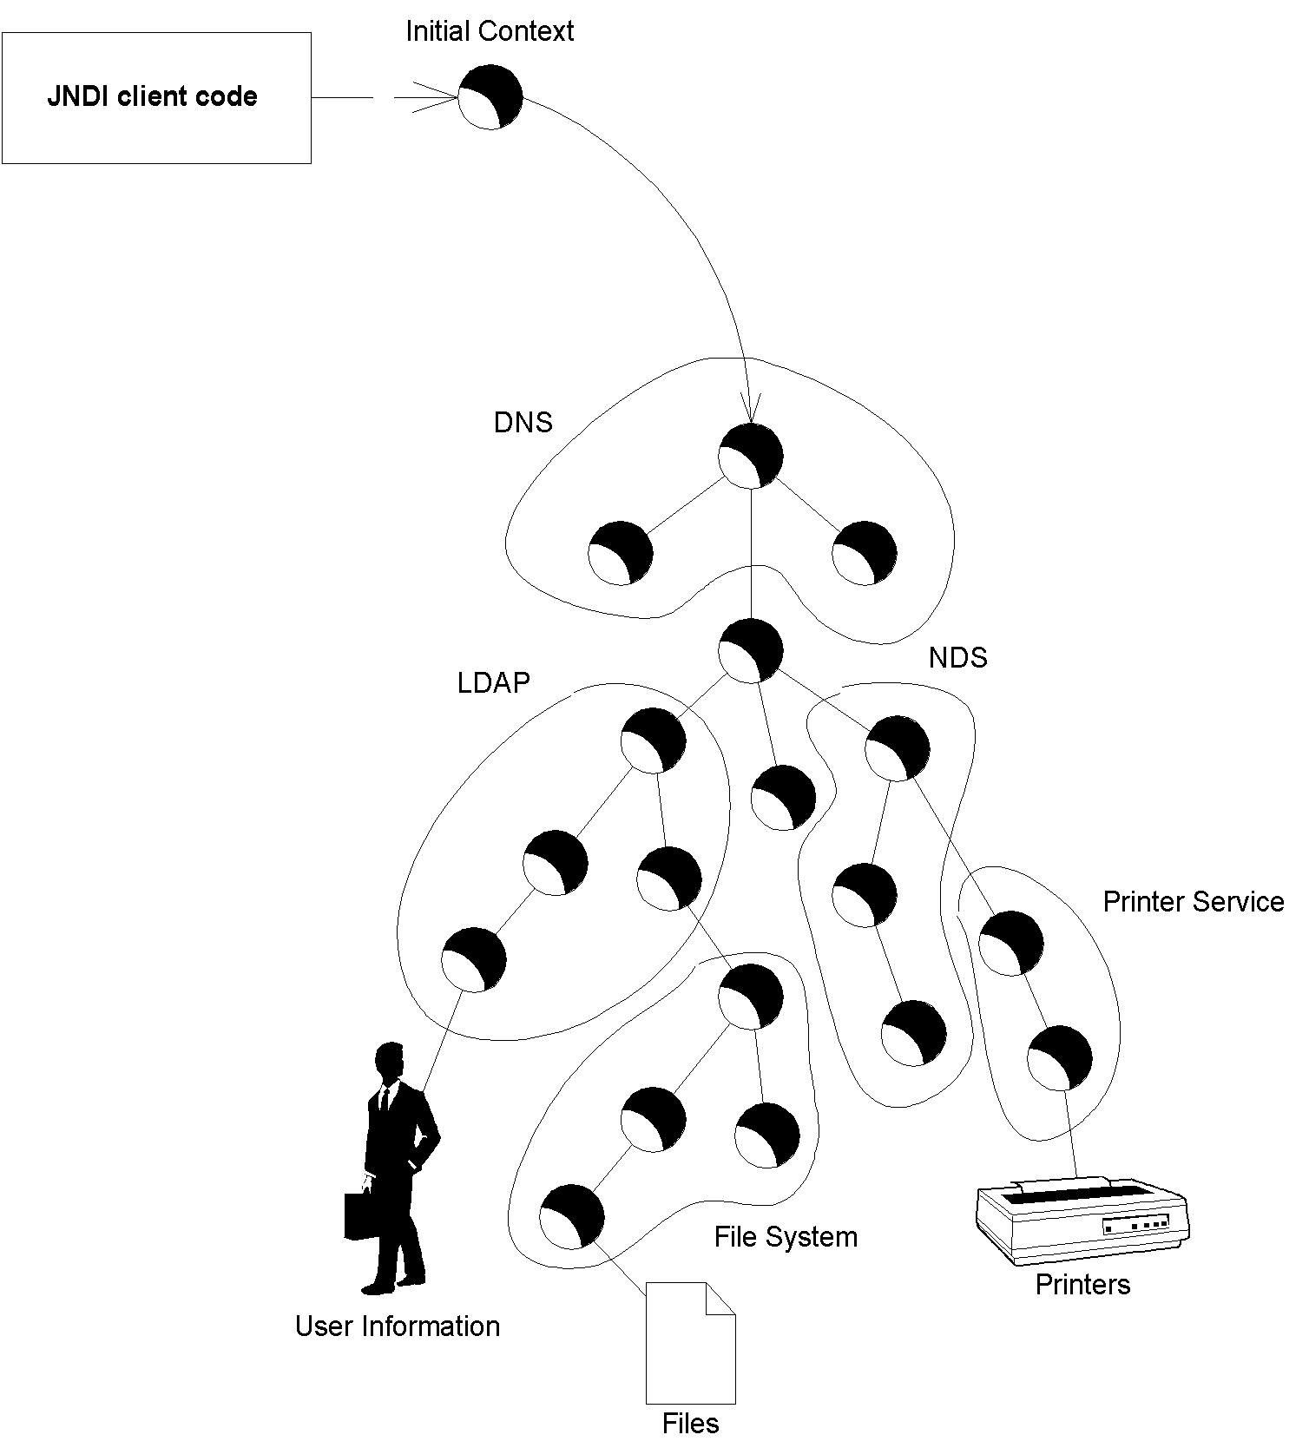
Figure X.X A composite (federated) namespace with an initial context.
Programming with JNDI
Now that you’ve seen the concepts behind JNDI, let’s put our theory into concrete use. Source X.X shows a simple JNDI example.
package examples;

public class InitCtx {

public static void main(String args[]) throws Exception {
// Form an Initial Context
javax.naming.Context ctx =
new javax.naming.InitialContext(System.getProperties());
System.err.println("Success!");
}
}
Source X.X InitCtx.java.
The code simply acquires an initial, and then the program completes. The specific JNDI driver that we use is based on the system properties passed in at the command-line. For example, to connect to your file system, you'd use Sun's file system JNDI service provider, which is a driver that connects you to your own hard disk to browse the file system. You would then run the program as follows:
java
-Djava.naming.factory.initial=
com.sun.jndi.fscontext.RefFSContextFactory
-Djava.naming.provider.url=
file:c:\
examples.InitCtx
The java.naming.factory.initial parameter identifies the class of the JNDI driver. Then, we identify the starting point on the file system that we want to begin navigating: specifically, the c:\ folder. This starting point is structured in the form of a Uniform Resource Locator (URL), and in JNDI it is called the provider URL because it’s a URL that the service provider accepts for bootstrapping.
We can reuse this same code to connect to an LDAP server as follows:
java
-Djava.naming.factory.initial=com.sun.jndi.ldap.LdapCtxFactory
-Djava.naming.provider.url="ldap://ldap.funet.fi:389/c=fi"
examples.InitCtx
As you can see, this data-driven mechanism of performing JNDI has its advantages. It allows you to avoid recompiling your Java code. It also enables non-Java savvy users to customize the behavior of your programs without modifying source code, which is important if you ship your products only as .class files.
Other JNDI operations
After acquiring the initial context, you could begin to execute JNDI operations, such as reading or writing data to and from the JNDI tree by using the other API calls available in JNDI. Here is a brief list of available operations that you can call on the context:@@@COMP: UL within SBT@@@
list() retrieves a list of contents available at the current context. This typically includes names of objects bound to the JNDI tree, as well as subcontexts. In a file system, this might be a list of file names and folder names. If you're connecting to a proprietary J2EE server's JNDI implementation, you might see a list of bound objects as well as subcontexts to which you can navigate.
lookup() moves from one context to another context, such as going from c:\ to c:\windows. You can also use lookup() to look up objects bound to the JNDI tree. The return type of lookup() is JNDI driver specific. For example, if you're looking up RMI-IIOP objects then you would receive a java.rmi.Remote object, while if you were looking up a file in a file system you would receive a java.io.File.
rename() gives a context a new name, such as renaming c:\temp to c:\tmp.
createSubcontext() creates a subcontext from the current context, such as creating c:\foo\bar from the folder c:\foo.
destroySubcontext() destroys a subcontext from the current context, such as destroying c:\foo\bar from the folder c:\foo.
bind() writes something to the JNDI tree at the current context. As with lookup(), JNDI drivers accept different parameters to bind().
rebind() is the same operation as bind, except it forces a bind even if there is already something in the JNDI tree with the same name.
Integrating RMI-IIOP and JNDI
Now that you've seen both RMI-IIOP and JNDI, let's see how to combine them together and complete our RMI-IIOP example. There are essentially two uses of JNDI with RMI-IIOP:
- An RMI-IIOP server first publishes itself to a JNDI tree using the JNDI API.
- A client then uses JNDI to lookup an RMI-IIOP server
This process is shown in Figure X.X.
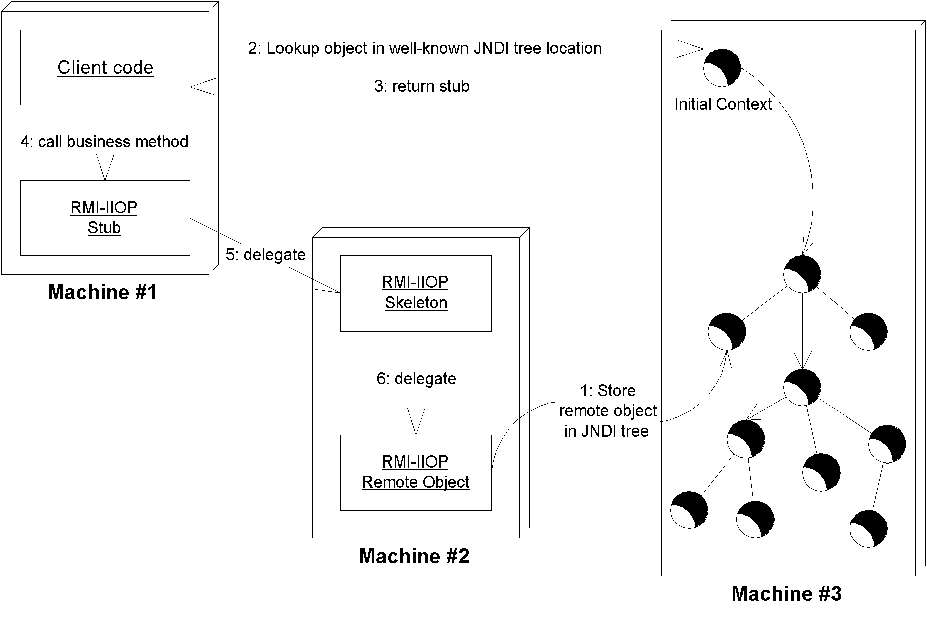
Figure X.X Bootstrapping with JNDI.
Your JNDI tree implementation is typically bundled with the J2EE server runtime. Therefore, when you startup your J2EE server, the JNDI tree runs in-process to the J2EE server and starts up as well. J2EE servers also ship with a JNDI driver that can connect to that JNDI tree implementation, which clients call.
Binding an RMI-IIOP server to JNDI
The source code for binding the RMI-IIOP server to the JNDI tree is in Source X.X
import javax.naming.*;

/**
* A helper class which starts our RMI-IIOP server
*/
public class Startup {

/**
* Our main() method starts things up
*/
public static void main(String args[]) throws Exception {

/*
* Start up our PKGenerator remote object. It will
* automatically export itself.
*/
PKGenerator generator = new PKGenerator();

/*
* Bind our PKGenerator remote object to the JNDI tree
*/
Context ctx = new InitialContext(System.getProperties());
ctx.rebind("PKGenerator", generator);
System.out.println("PKGenerator bound to JNDI tree.");

synchronized (generator) {
generator.wait();
}
}
}
Source X.X Startup.java
The startup class instantiates a remote object, acquires an initial context, binds the remote object to the context, and then waits for a client to call. It assumes that your J2EE server's JNDI implementation is already up-and-running. Note that you must supply your J2EE server's JNDI driver initialization parameters via the command line, as we showed earlier in this chapter when we ran our JNDI Initial Context example. Check your server's documentation or see the book's accompanying source code for this.
Looking up an RMI-IIOP server with JNDI
Our client code that looks up the RMI-IIOP server via JNDI is in Source X.X.
import javax.naming.*;
import java.rmi.*;

public class Client {

public static void main (String[] args) throws Exception {

// Lookup the remote object via JNDI
Context ctx = new InitialContext(System.getProperties());
Object remoteObject = ctx.lookup("PKGenerator");

// Cast the remote object, RMI-IIOP style
IPKGenerator generator = (IPKGenerator)
javax.rmi.PortableRemoteObject.narrow(
remoteObject, IPKGenerator.class);

// Generate a PK by calling the RMI-IIOP stub
System.err.println(generator.generate());
}
}
Source X.X Client.java.
Our client code is self-explanatory, with one exception. After looking up our remote object, we do a very strange operation: javax.rmi.PortableRemoteObject.narrow(). This is a static method on an RMI-IIOP class called PortableRemoteObject. This method casts the generic object that we looked up via JNDI to our RMI-IIOP interface type. This narrow() operation is required whenever you lookup an RMI-IIOP object via JNDI. Why do we need it, and why don't we just cast it using a regular Java cast? The short answer is CORBA interoperability. And if you're really curious, the long answer is in Appendix X.
As with the server, to run the client, you must supply your J2EE server's JNDI driver initialization parameters via the command line, as we showed earlier in this chapter when we ran our JNDI Initial Context example. Check your server's documentation or see the book's accompanying source code for this.
Summary
In this chapter, we've learned how Java RMI-IIOP and JNDI are fundamental underlying technologies in an EJB deployment. We looked at RMI-IIOP’s architecture, comparing it to traditional RPCs. We examined stubs and skeletons, parameter passing, and object serialization. We concluded our RMI-IIOP discussion by introducing a sample primary key generator RMI-IIOP server.
Next, we delved into JNDI. We looked at the basics of naming and directory concepts, and saw how to acquire an initial context. We then investigated how to bind and lookup an RMI-IIOP object using JNDI.
Now that you know about RMI-IIOP and JNDI, read Chapter X to learn about how these APIs are used with EJB. Interested readers who want to learn more about RMI-IIOP and JNDI should consult the following references:
The RMI-IIOP and JNDI Tutorials. These are available for free on the Sun Microsystems Web site.
The RMI-IIOP and JNDI Specifications. The specifications define the core of RMI-IIOP and JNDI. They are a bit more technical, but it should not be tough now that you’ve read this appendix.

